Sri Dharmasthala Manjunatheshwara
College of Ayurveda & Hospital, Hassan

RGUHS Ranks in Final Year MD/MS (Ayurveda) Exam Held On Oct/Nov 2020
First Rank
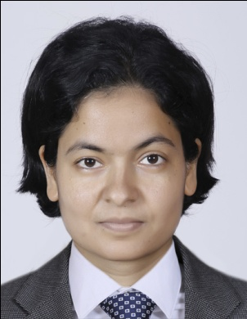 |  | 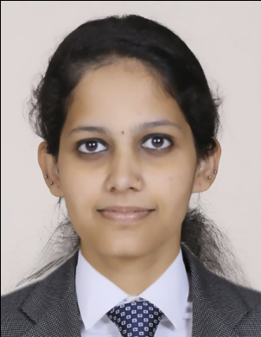 |  | 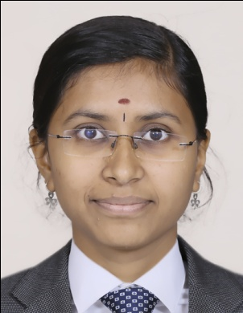 |  | 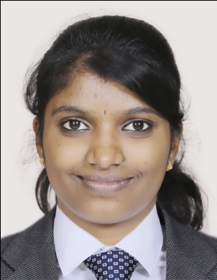
Dr. Poonam Nepal  MD (Ayu)- Samhita |  | Dr. Medha B Bhat  MD (Ayu)- Dravyaguna |  | Dr. Mangala J G P  MD (Ayu)- Kaumarabhritya |  | Dr. NIthya P R  MD (Ayu)- Manasaroga
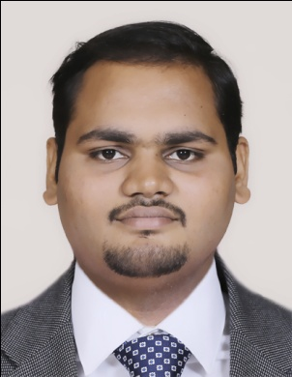 |  | 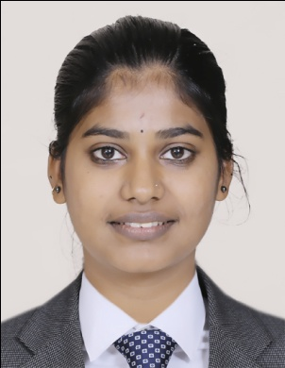 |  | 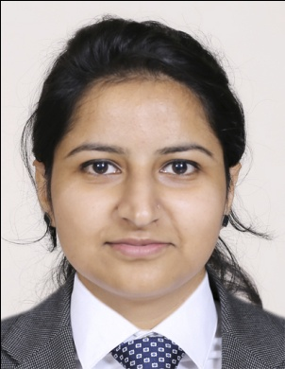 |  | 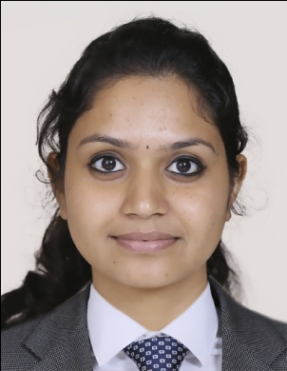
Dr. Animesh Mohan  MD (Ayu)- Panchakarma |  | Dr. Swathimutthu B N  MS (Ayu)- Prasuti Tantra & Stree Roga |  | Dr. Monika Gupta  MD (Ayu)- Roga Nidana |  | Dr. Mahathi S M  MD (Ayu)- Swasthavritta
Second Rank
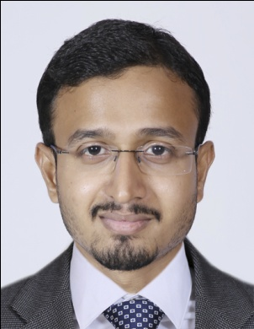 |  | 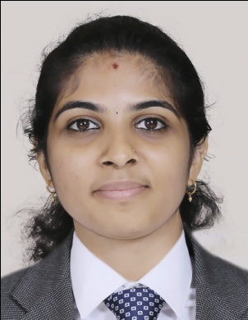 |  | 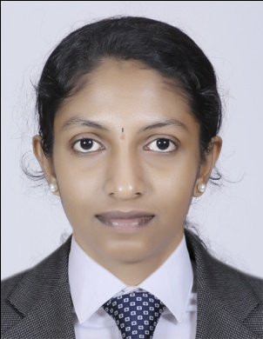 |  | 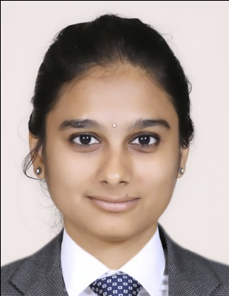
Dr. Powar Vibhu Sudhakar  MD (Ayu)- Kayachikitsa |  | Dr. Chaithra N  MD (Ayu)- Kriya Shareera |  | Dr. Sushmitha P N  MD (Ayu)- Manasaroga |  | Dr. Chaithra D M  MS (Ayu)- Prasuti Tantra & Stree Roga

RGUHS Ranks in Final Year MD/MS (Ayurveda) Exam Held On Oct/Nov 2020
Third Rank
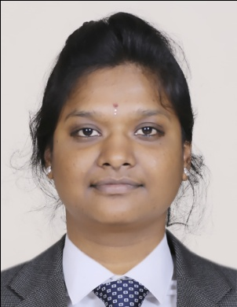 |  | 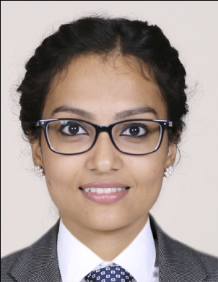 |  | 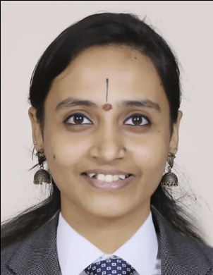 |  | 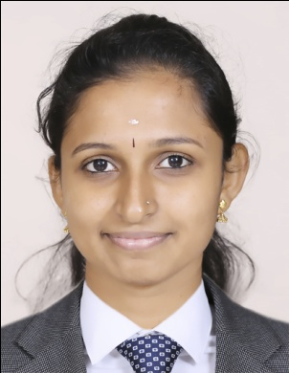
Dr. Pabbisetti Venkata Lakshmi Sujana  MD (Ayu)-Kaumarabhritya |  | Dr. Sangeeta S  MD (Ayu)- Panchakarma |  | Dr. Kiran A  MS (Ayu)- Prasuti Tantra & Stree Roga |  | Dr. Saranya k  MD (Ayu)- Roga Nidana
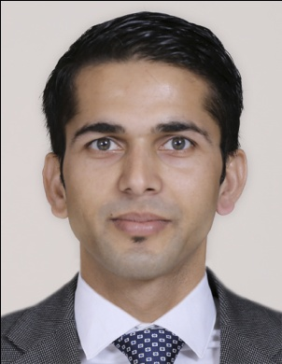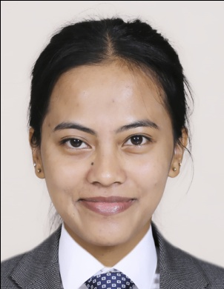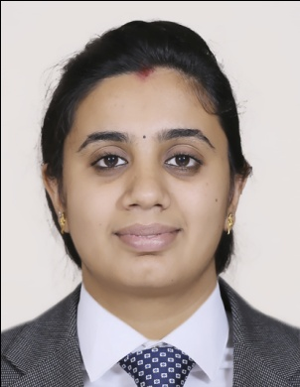
Dr. Krishna Prasad Gyawali Dr. Daiarisa Rymbai Dr. Rebecca Baby
MS (Ayu)- Shalya Samanya MD (Ayu)- Shareera Rachana MD (Ayu)- Swasthavritta
Fourth Rank
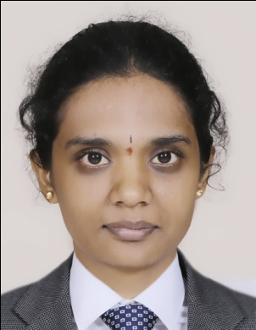 |  | 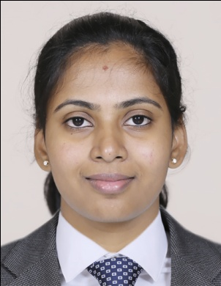 |  | 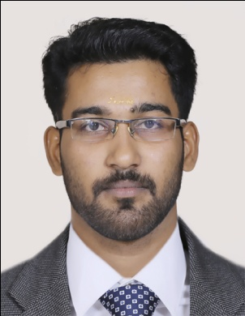 |  | 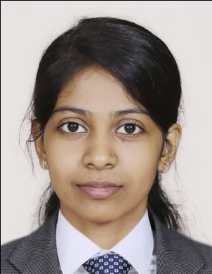
Dr. Shruthi K  MD (Ayu)- Samhita |  | Dr. Manasa G H  MD (Ayu)-Kaumarabhritya |  | Dr. Arun M  MD (Ayu)- Manasaroga |  | Dr. Shameeabanu Nabeesab  MD (Ayu)- Panchakarma
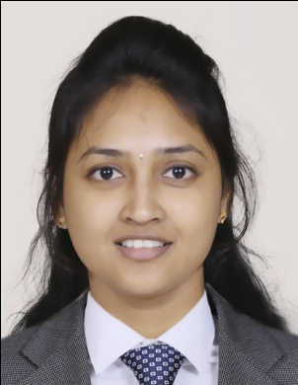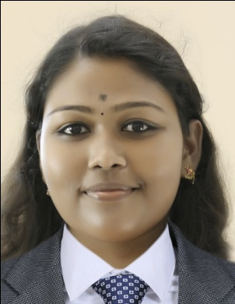
Dr. Ramya H Dr. Simi C P
MS (Ayu)- Prasuti Tantra & Stree Roga MD (Ayu)- Shareera Rachana

RGUHS Ranks in Final Year MD/MS (Ayurveda) Exam Held On Oct/Nov 2020
Fifth Rank
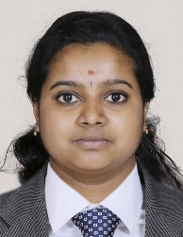 |  | 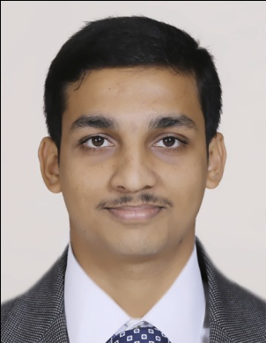 |  | 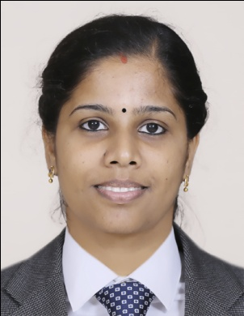 |  | 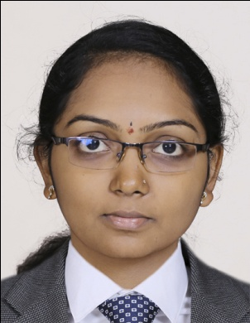
Dr. Arya Subhash  MD (Ayu)- Agada Tantra |  | Dr. K Kiran  MD (Ayu)- Kayachikitsa |  | Dr. Sree Renjini M G  MS (Ayu)- Prasuti Tantra & Stree Roga |  | Dr. Pooja B  MD (Ayu)- Rasashastra & Bhaishajya Kalpana
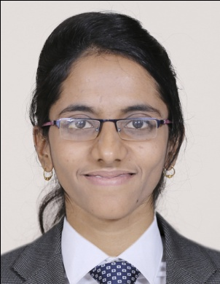
Dr. Muteeba Naz
MD (Ayu)- Shareera Rachana

Sixth Rank
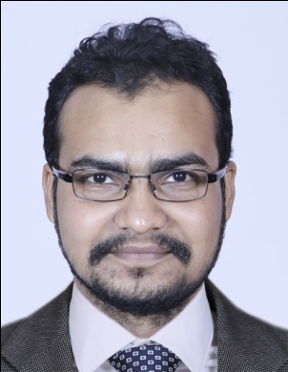 |  | 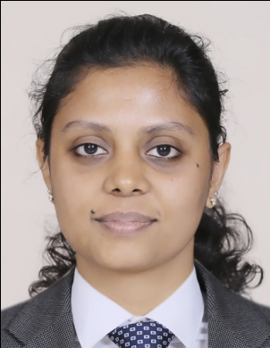 |  | 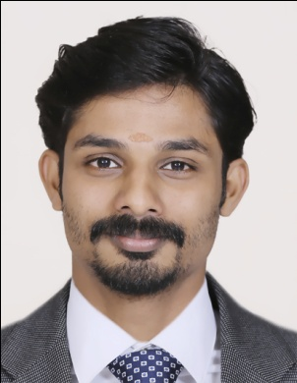 |  | 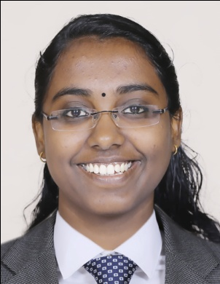
Dr. Sri Krishna S  MD (Ayu)- Agada Tantra |  | Dr. Reshma K Raj  MD (Ayu)- Kaumarabhritya |  | Dr. Kamaldeep  MD (Ayu)- Manasaroga |  | Dr. Athira K S  MD (Ayu)- Swasthavritta

RGUHS Ranks in Final Year MD/MS (Ayurveda) Exam Held On Oct/Nov 2020
Seventh Rank
 |  |  | 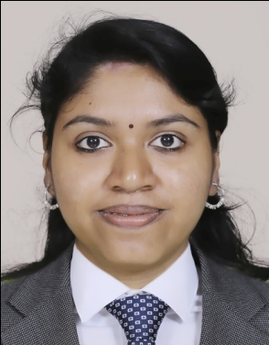 |  |  |  |  | 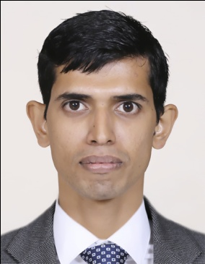
 |  |  | Dr. Haritha Mathew P  MD (Ayu)- Dravyaguna |  |  |  |  | Dr. Jayram Krishna M  MD (Ayu)- Roganidana
Eighth Rank
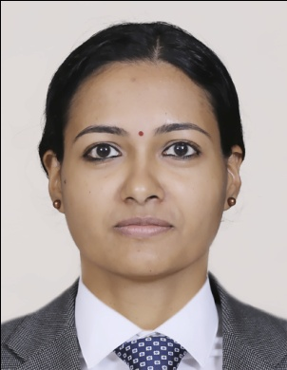 |  |  |  | 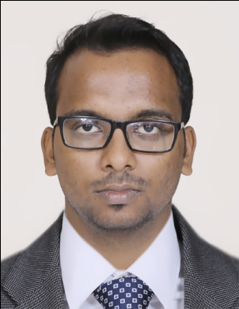 |  |  | 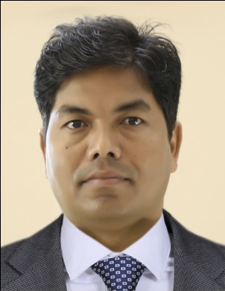 |  |  |  | 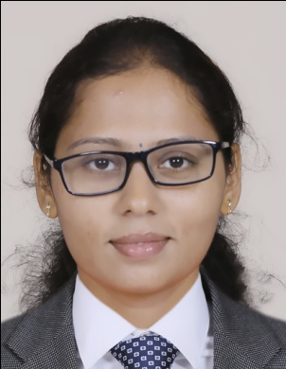
Dr. Jasmine John  MD (Ayu)- Roganidana |  |  |  | Dr. Anish Jose S  MS (Ayu)- Shalakya Tantra |  |  | Dr. Surendra Chaudhary  MD (Ayu)- Shareera Rachana |  |  |  | Dr. Nuthan R  MD (Ayu)- Swasthavritta
Ninth Rank
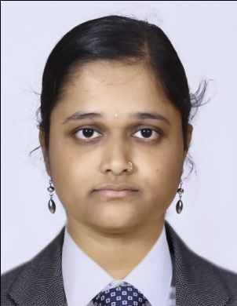 |  |  |  | 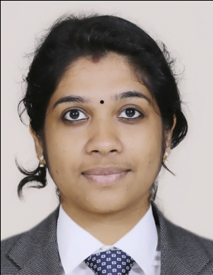 |  |  | 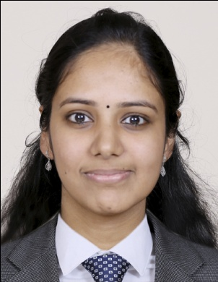 |  |  |  | 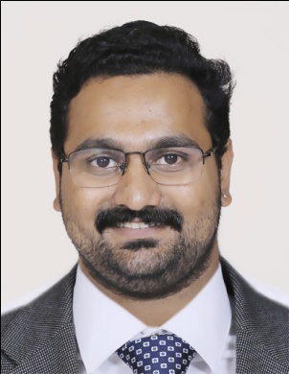
Dr. Anusha G Ekabote  MD (Ayu)- Samhita |  |  |  | Dr. K S Sreedevi  MD (Ayu)-Kayachikitsa |  |  | Dr. Aswathy Narayanan  MS (Ayu)- Shalakya Tantra |  |  |  | Dr. Hari Sankar M S  MD (Ayu)- Swasthavritta
Tenth Rank
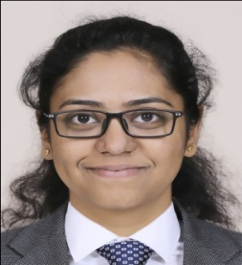
Dr. Rachana M S
MD (Ayu)- Kayachikitsa

