Provisional List of Students for the Award of Endowment Sponsored and RGUHS Gold Medals/ Cash Prize for the 23rd Annual Convocation of RGUHS Scheduled to be held in First Week of February 2021
Highest marks in  M.S Ayurveda- Prasuti Evum Striroga | Dr. Swathimutthu B N | 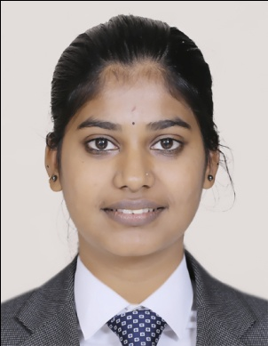
Highest marks in  M.D Ayurveda- Dravyaguna Vigyan | Dr. Medha B Bhat | 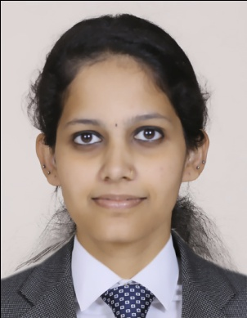
Highest marks in  M.D Ayurveda- Roganidan Evum Vikriti Vigyan | Dr. Monika Gupta | 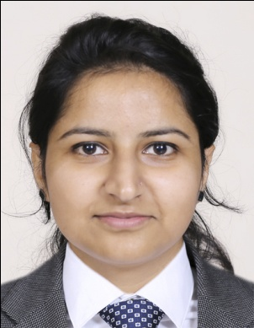

Highest marks in  M.D Ayurveda- Swasthavritta | Dr. Mahathi S M | 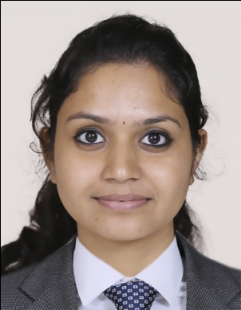
Highest marks in  M.D Ayurveda- Samhita and Siddhanta | Dr. Poonam Nepal | 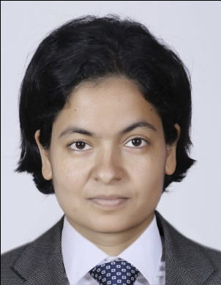
Highest marks in  M.D Ayurveda- Panchakarma | Dr. Animesh Mohan | 