SDM College of Ayurveda & Hospital, Hassan
RGUHS Ranks in First Year MD/MS (Ayurveda) Exam held on Oct/Nov 2020
First Rank
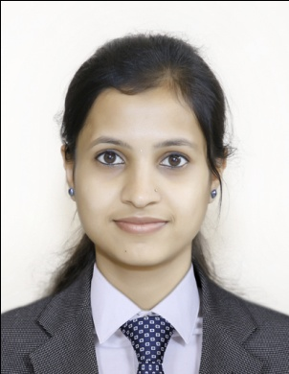 |  | 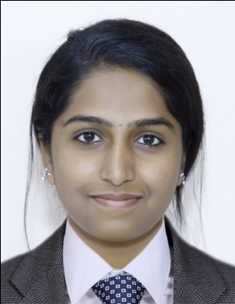 |  | 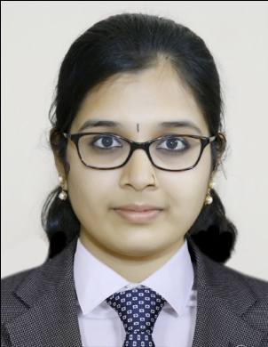 |  | 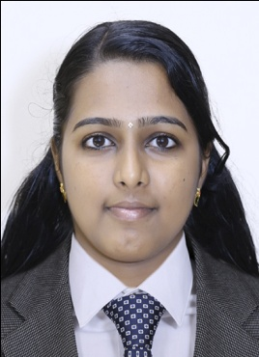
Dr. Deepa P  MD (Ayu)- Agada Tantra |  | Dr. Meghana D R  MD (Ayu)- Kriya Shareera |  | Dr. Kamalashree K M  MD (Ayu)- Rachana Shareera |  | Dr. Ashitha N K  MD (Ayu)- Swasthavritta
Second Rank
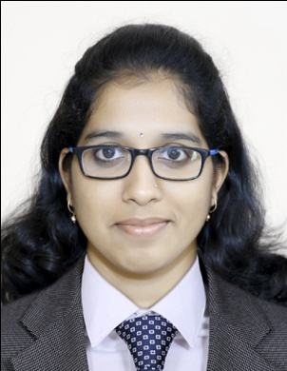 |  | 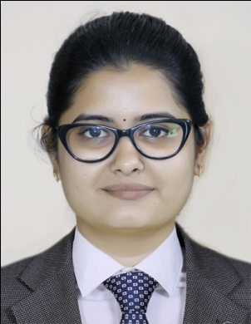 |  | 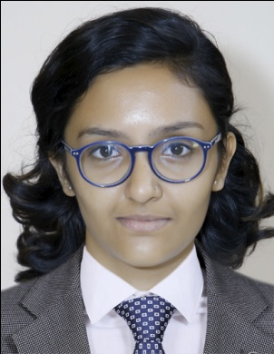 |  | 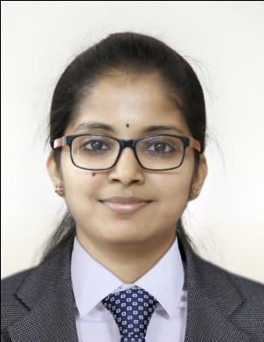
Dr. Shreeraksha N  MD (Ayu)- Agada Tantra |  | Dr. Priya Jarimalli  MD (Ayu)- Kriya Shareera |  | Dr. Malavika B  MD (Ayu)- Manasaroga |  | Dr. Deeksha R  MS (Ayu)- Shalakya Tantra
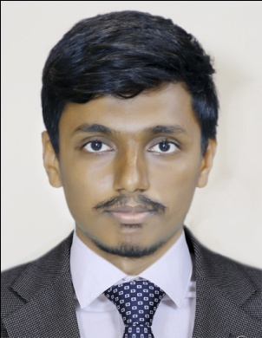
Dr. Gowda Ketan Annayya
MD (Ayu)- Rachana Shareera

Third Rank
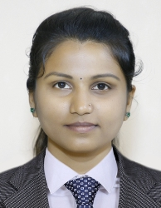 |  | 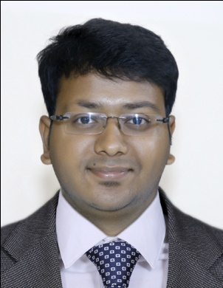 |  |  |  | 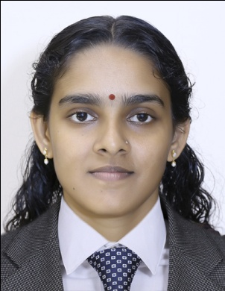 |  |  |  | 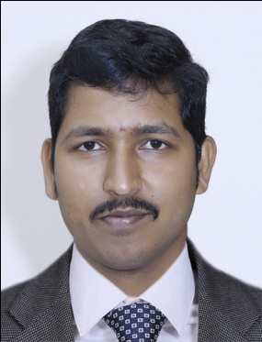
Dr. Akshatha K Shirwar  MD (Ayu)- Agada Tantra |  | Dr. Abishek Bharadwaj B U  MD (Ayu)- Dravyaguna |  |  |  | Dr. Binisha C  MD (Ayu)- Kaumarabhritya |  |  |  | Dr. Manjunatha B Sunagar  MD (Ayu)- Kriya Shareera
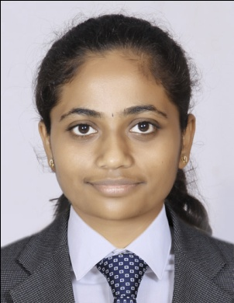
Dr. Sushmitha S Hadimane, MS (Ayu)- Prasuti Tantra & Stree Roga
Fourth Rank
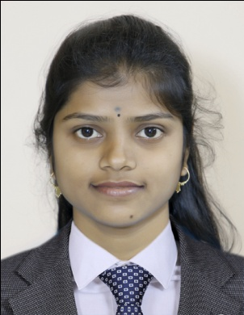 |  | 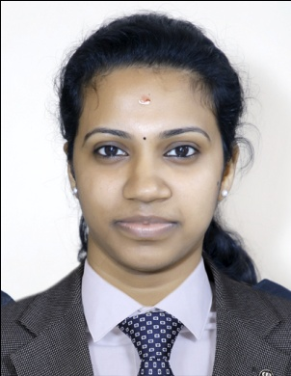 |  | 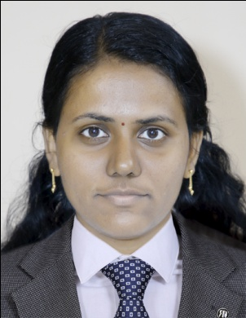 |  |  |  | 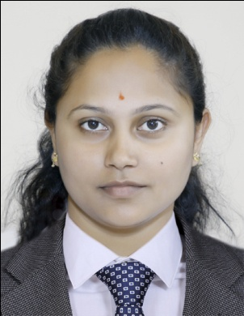
Dr. Shashikala Kurbet  MD (Ayu)- Kriya Shareera |  | Dr. Aiswarya E K  MD (Ayu)- Roganidana |  | Dr. Jisi V S  MS (Ayu)- Shalya Tantra |  |  |  | Dr. Sneha H S  MD (Ayu)- Rachana Shareera

Fifth Rank
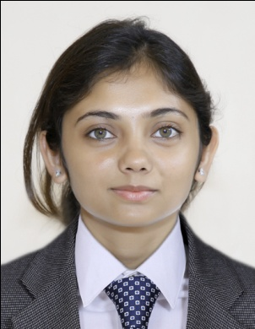 |  | 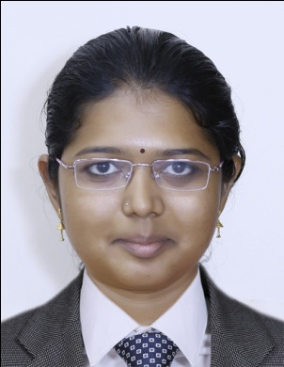 |  | 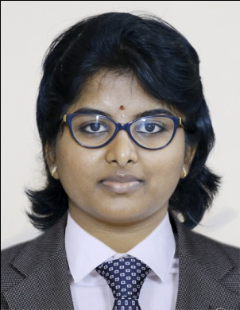 |  | 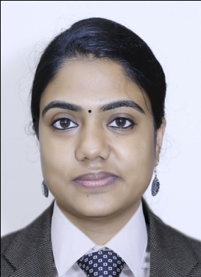
Dr. Aditi Gandhi  MD (Ayu)- Dravyaguna |  | Dr. Akshaya G  MD (Ayu)- Roganidana |  | Dr. Deekshitha S  MD (Ayu)- Rasashastra & Bhaishajya Kalpana |  | Dr. Sneha P K  MS (Ayu)- Shalakya Tantra
Sixth Rank
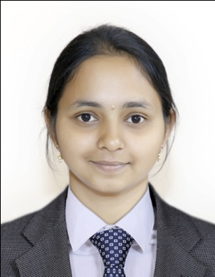 |  | 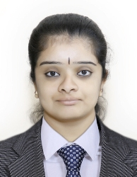 |  | 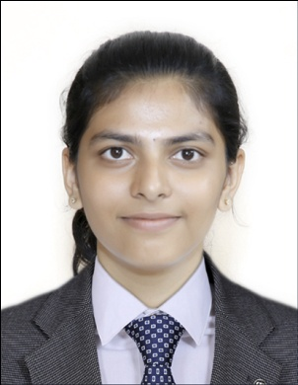 |  | 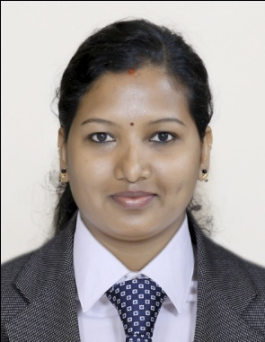
Dr. Asha Vithal Bhat  MD (Ayu) –Rasashastra & Bhaishajya Kalpana |  | Dr. Anushree C G  MD (Ayu)- Agada Tantra |  | Dr. Teerthashre N S  MD (Ayu)- Samhita & Siddhanta |  | Dr. Akshata  MD (Ayu)- Dravyaguna
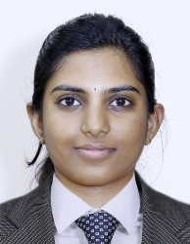
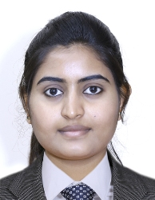
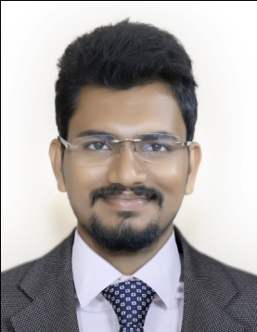
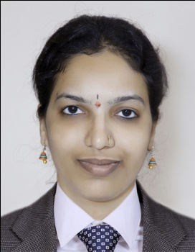
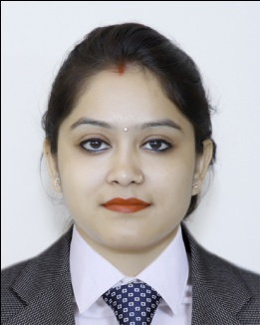
Dr. Manisha Chaudhary Dr. Thanushree Yogee Dr. S Y S Vidyasagar Badisa Dr. Meghana A M Dr. Ritheka B Rao
MD (Ayu)- Kaumarabhritya MD (Ayu)- Manasaroga MS (Ayu)- Shalakya Tantra MS (Ayu)- Shalya Tantra MS (Ayu)-Shalya Tantra

Seventh Rank
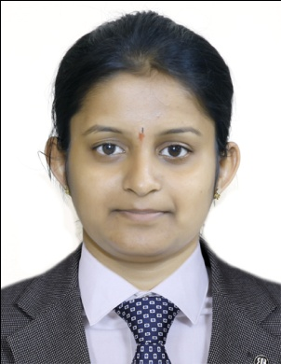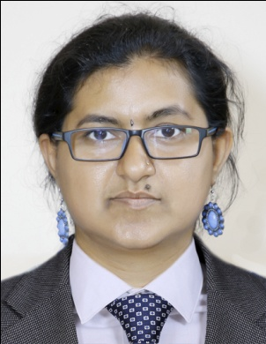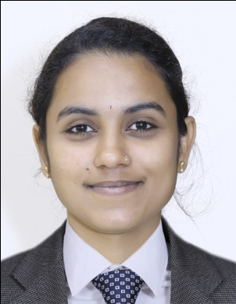
Dr. Rakshitha K S Dr. Vasavi Varambally Dr. Vani Nayak
MD (Ayu)- Samhita & Siddhanta MD (Ayu)- Manasaroga MD (Ayu)- Roganidana
Eighth Rank
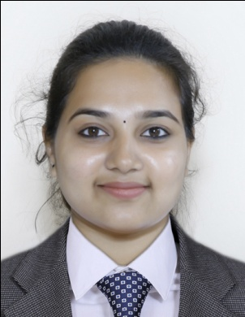 |  | 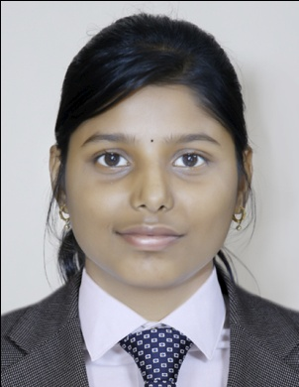 |  | 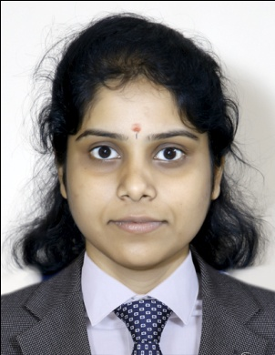 |  | 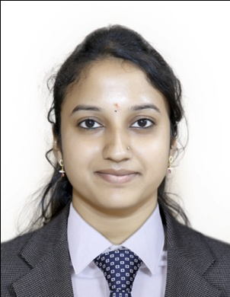
Dr. Sangala Priyanka  MD (Ayu)- Dravyaguna |  | Dr. Ankita Kishor Kale  MD (Ayu)- Manasaroga |  | Dr. Laxmi Anant Rao Koppar  MD (Ayu)- Roganidana |  | Dr. Ramya M P  MD (Ayu)- Rasashastra & Bhaishajya Kalpana
Ninth Rank
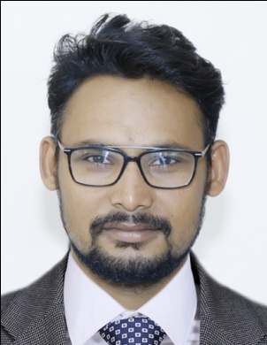 |  | 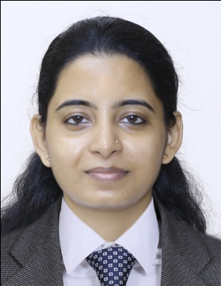 |  | 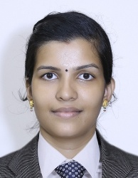 |  | 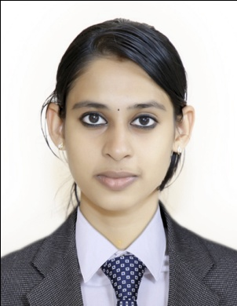
Dr. Ashraf Ali  MD (Ayu)- Kaumarabhritya |  | Dr. Rajouri Joshi  MD (Ayu)- Kayachikitsa |  | Dr. Surya K P  MD (Ayu)- Panchakarma |  | Dr. Parvathy Sreekumar  MD (Ayu)- Roganidana
Tenth Rank
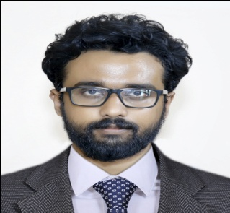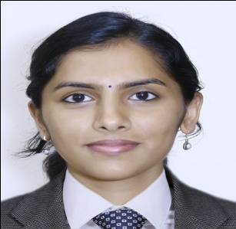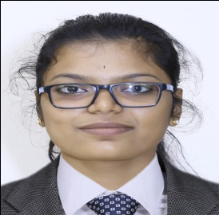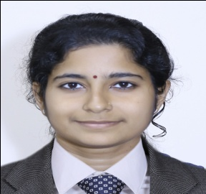
Dr. Abby Chacko Dr. Nehaa Srinivasan Dr. Vandana H M Dr. Radhika Rani V
MD (Ayu)- Kaumarabhritya MD (Ayu)- Kayachikitsa MS (Ayu)- Prasuti Tantra & Stree Roga MD (Ayu)- Roganidana

